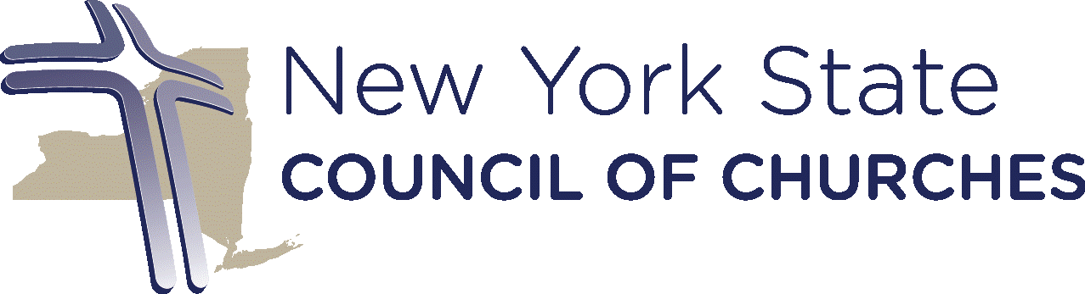
July 31, 2024
The Honorable Kathy Hochul
Governor
State of New York

The Honorable Eric Adams
Mayor
The City of New York
Dear Governor Hochul and Mayor Adams:
On behalf of the New York State Council of Churches and our 7,500 congregations, I write to bring to your immediate attention to a deeply concerning inclusion of an anti-Muslim float at India Day Parade scheduled for August 18, 2024, in the heart of New York City.
The parade, organized by the far-right Hindu group Vishwa Hindu Parishad of America (VHPA), in collaboration with the Indian consulate, alongside Bochasanwasi Akshar Purushottam Swaminarayan Sanstha (BAPS) and the Federation of Indian Associations (FIA), poses a grave threat to the values of inclusivity and tolerance for people of all faiths, that New York City and the state of New York proudly uphold.
The VHPA, an offshoot of India’s Vishwa Hindu Parishad (VHP), has been designated as a “militant religious organization” by the Central Intelligence Agency’s (CIA) World Factbook. Georgetown University's Bridge Initiative also identifies VHPA as an Islamophobic group. Savera, a research project run by a coalition of civil rights groups, identifies the VHPA as “as a key part of a global far-right ecosystem” due to its “collaborations with other supremacist organizations and ideologies [and] their attacks on US civil society organizations”. Moreover, BPAS is under active FBI investigation for forced labor and exploitation of low-caste laborers from India. These organizations plan to use the 42nd Annual India Day Parade to propagate hate and instill fear among American Muslims by featuring a divisive float of the Ram Temple, a symbol of violence, historical injustice and religious intolerance.
The Ram Temple stands on the ruins of the historic Babri Mosque, which was demolished on December 6, 1992, by a mob of over 150,000 Hindu zealots. The demolition sparked widespread riots across India, resulting in the deaths of thousands, predominantly Muslims. In November 2019, the Supreme Court of India controversially awarded the site to Hindus for the construction of the temple, thereby legitimizing an egregious act of violence against a Muslim place of worship. Despite this, the court acknowledged the criminality of the mosque's destruction, noting it as an “egregious violation of the rule of law.”
The inauguration of the Ram Temple in January 2024 by India’s Hindu supremacist Prime Minister Narendra Modi has further exacerbated religious tensions in the country, resulting in widespread violence at the hands of what the Washington Post called “triumphant Hindu mobs” and attacks on multiple other places of worship.
The proposed float for the parade is a blatant attempt to glorify the demolition of the Babri Mosque and celebrate ongoing violence and terror against 200 million Indian Muslims. This is not merely a cultural display but a vulgar celebration of anti-Muslim hate, bigotry, and religious supremacy.
In August 2022, similar far-right Hindu groups transformed the India Day parade in Edison, New Jersey, into a hate event by displaying a bulldozer, symbolizing the demolition of Muslim homes in India, alongside pictures of Prime Minister Modi and other Hindu supremacist leaders. This incident was condemned by U.S. Senators Cory Booker and Bob Menendez and investigated by the Middlesex County Prosecutor’s Office and Edison Police Department as a “bias incident.”
As a Christian organization which works hard every day to honor religious diversity and to stop the abuse of religious nationalisms in New York and around the world, we bring this matter to your attention because it typifies the shabby treatment that all religious minorities, Dalits, and Adivasi’s (native people of India) experience at the hands of the Hindu nationalist government. In addition to the destruction of mosques, many Christian churches are burned or reappropriated while their leaders are harassed, beaten, killed or incarcerated. The parade which includes this float, emboldens Hindu extremists, who distort the Hindu faith, to advance their supremacist agenda in the United States and India by glorifying acts of violence injustice and discrimination against Muslims and all religious minorities in India.
New York State Council of Churches very much values your efforts to welcome and celebrate diverse religious communities. Please know that allowing or tacitly supporting such a hateful and bigoted celebration would be hurtful and not uphold the values of inclusion which we know are important to you. We ask that you take immediate and decisive measures to prevent the inclusion of a polarizing and divisive float in the parade. It is imperative to protect our diverse communities from such divisive and inflammatory actions and ensure that New York remains a safe and welcoming place for all its residents while lifting up the promise of a truly democratic India where everyone is treated equally regardless of religion.

Sincerely,

Peter Cook
Executive Director

https://fianynjct.org/bi-weekly/flipbook/DIASPORA-BI-WEEKLY-Wednesday-July-10-2024-Issue-119.html
https://indianexpress.com/article/india/cia-names-vhp-bajrang-dal-as-religious-militant-organisations-in-world-factbook-5218249/
https://bridge.georgetown.edu/research/factsheet-vishwa-hindu-parishad-of-america-vhpa/
https://www.wearesavera.org/wp-content/uploads/2024/02/The-Global-VHPs-Trail-of-Violence-v2.pdf
https://www.nytimes.com/2021/11/10/nyregion/baps-hindu-forced-labor.html
https://www.nytimes.com/1992/12/07/world/hindu-militants-destroy-mosque-setting-off-a-new-crisis-in-india.html
https://www.livelaw.in/top-stories/babri-mosque-demolition-an-egregious-violation-of-the-rule-of-law-wrong-committed-must-be-remedied-sc-read-judgment-149643
https://time.com/6564148/ayodhya-ram-temple-modi-india/
https://www.washingtonpost.com/world/2024/01/25/india-ayodhya-hindu-nationalism-attacks/
https://www.nytimes.com/2022/09/25/nyregion/bulldozer-indian-parade-new-jersey.html
https://www.booker.senate.gov/news/press/booker-menendez-staff-meet-with-iamc-cair-nj-and-indian-american-groups-following-india-day-parade-incident

